The American University in Cairo
School of Science and Engineering
Spring Semester, 2015 Dr. Sherine Ahmed El Baradei
ENGR 313
Computer Project
Roots of Non-Linear Equations
And
Solving Linear Equations Simultaneously

- Develop, and test a computer program written in C++ or MATLAB language to find roots of non-linear equations. Your algorithm should be based on the Bisection Method, Secant Method, False Position Method, and Newton-Raphson methods.

Use the computer code you developed to solve for all real roots of the following equations (use graphical method – with Excel - to allocate all roots); Use the proper method with the proper function. Also if some functions could be solved by more than one method than solve them with all those compatible methods. Compare between the answers of the methods for the functions that could be solved with more than one method:
- 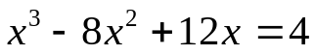 (0.474572, 1.3691)
- f(x) = -12 -21x + 18x - 2.75x(-0.41469, 2.2198, 4.7403)
- 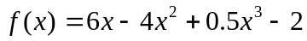 (0.474572, 1.3691, 6.1563)
- 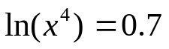)+-1.1912(
- 7 sin(x) = 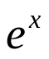(-25.1327412287166, -21.9911485751688, -18.8495559206084, -15.707693894778, -12.5663701161672, -9.42478948913899, -6.28291845844457, -3.14772834675799, 0.17017999375836, 1.89305902941532)

- Develop, and test a computer program written in C++ or MATLAB language to solve for the following sets of linear equations simultaneously using the Gauss Jordan's Elimination Method and the Jacobi Method. For solving with Jacobi, let 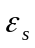= 0.01%
0.5, 8, -6
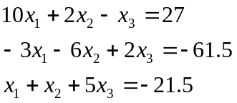
Compare between the two methods in light of the results obtained by them.

- Submission requirements:
- Pseudo code
- Flowchart
- Computer program (including a disk with your operating code, and a hard copy). You should submit any data that will clarify your work , i.e , definition of your variables, and your development and solution procedures.
- Results of program testing (solution of the equations of #2)
- Include any graphical solution that you in part 2 used to determine your initial guesses of the root (i.e Excel, graph done by hand, ….etc.)

Note: You can work in groups of 4 students.

